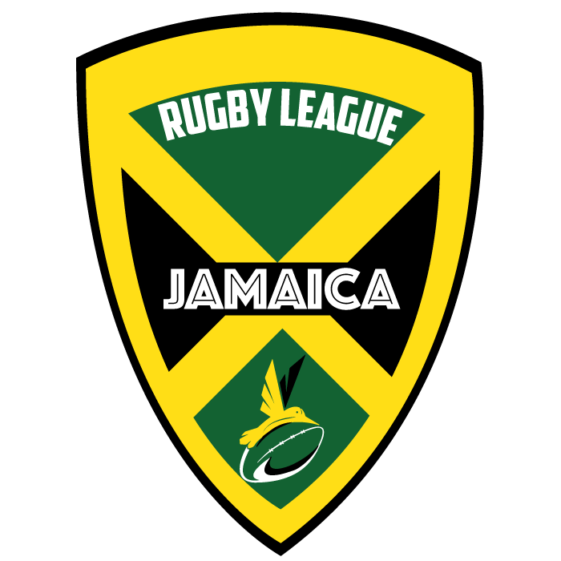
JRLA Concussion Policy. Effective September 5, 2015, for all domestic competitions in Jamaica.

Summary
The most important element in the management of concussion MUST ALWAYS be the welfare of the player, in both the short and long term.
Concussion is a disturbance in brain function resulting from trauma that is transmitted to the brain either directly or indirectly. There are no structural changes and the changes that do occur are temporary and recover spontaneously.
Complications can occur if the player is allowed to continue playing before they have recovered from the concussion. Therefore a player who is suspected of having a concussion must be taken out of the game or training session immediately. Such a player should not be returned to play in the same game.
The management of head injury may be difficult for non medical personnel. It is often not clear whether you are dealing with concussion or there is a more severe structural head injury, especially in the early phases of the injury.
Therefore it is imperative that all players with concussion or suspected of having a concussion need URGENT medical assessment.
In the period following a concussion, a player should not be allowed to return to play or train until they have had a formal medical clearance.

What is Concussion?
“Traumatic Brain Injury” (TBI) is the term used to describe injuries to the brain that are caused by trauma. The most severe injuries involve structural damage e.g. fractures of the skull, bleeding in or around the brain. These structural injuries require urgent medical attention.
Concussion falls into the milder spectrum of TBI and involves a disturbance of brain function with no structural damage or permanent injury to the brain.
Concussion is caused by trauma to the brain which can be either direct (head clash) or indirect (shoulder charge or tackle). When the force is transmitted to the brain it can “stun” the nerve tissue and affect the way the nerves work. This can result in a number of symptoms and signs depending on the area of brain which is affected.
Symptoms include headache, blurred vision, dizziness, nausea, poor balance, fatigue and feeling “not quite right”. A concussed player may also exhibit confusion, memory loss and reduced ability to think clearly and process information. Loss of consciousness is not common and occurs in 10-15% of cases of concussion in Rugby League. It is important to understand that a player does not have to lose consciousness to have concussion.
The essential injury in concussion is functional malfunction rather than structural damage. The changes that occur are temporary and recover spontaneously if managed correctly. The recovery period and process varies from person to person and injury to injury. Most cases of concussion in rugby league recover within 7-14 days from the day of injury, although in a small number of cases the recovery time may be weeks to months.
How common is concussion in Rugby League?
Concussion is relatively common in rugby league. In the past 4-5 years the incidence in the NRL has been 5-7 concussions per team per season. The rate of concussion seems to be similar in all levels of competition.
What are the potential complications following concussion?
The complications which can occur following a concussion are:
• Increased risk of other injury (due to reduction in reaction time) or repeated concussion (with the second injury often much more severe than the first)
• Prolonged symptoms
• Symptoms of depression and other psychological problems
• Severe brain swelling (especially in young players) and
• Long term brain malfunction.
Complications are not common. The risk of complications is increased by allowing the player to return to play (or training) before they have recovered completely. Therefore it is essential to recognise concussion, make the diagnosis and keep the player out of training and competition until the player has recovered completely.
Concussion can cause problems with memory and processing of information, which interferes with the player’s ability to learn in the classroom. Therefore a child should not return to school until cleared by a medical practitioner to do so.

Steps in Management of Concussion
1. Presence of any symptoms or signs suggestive of concussion e.g. stunned, confused, memory problems, balance problems, headache, dizziness, “not feeling right”
>>>
2. Apply first aid, including cervical spine immobilisation if indicated
>>>
3. Remove from the ground. Assess using CRT (Concussion Recognition Tool)
>>>
4. Presence of any of the following: loss of consciousness, worsening confusion, vomiting, worsening headache.
>>>
YES - Call an Ambulance and refer to hospital
NO - Do NOT allow player to return to play. Refer to medical practitioner for assessment, either at the ground, local medical centre or hospital emergency department
N.B. Any player with loss of consciousness, basic first aid principles should be applied i.e. Airways, Breathing, CPR (DRSABC). Care must always be taken with the player’s neck, as it may have also been injured in the collision. An ambulance should be called and these players transported to hospital for assessment and management.
Game-Day Management
The most important steps in the early management of concussion include:
• Recognising the injury
• Removing the player from the game and
• Referring the player to a medical practitioner for assessment
Recognising the Injury (Making the Diagnosis)
Visible Clues: when to suspect concussion
• Loss of consciousness or non responsive
• Lying on the ground-not moving or slow to get up
• Unsteady on feet/ Balance problems/ poor coordination
• Grabbing/ clutching at head
• Dazed, blank or vacant look
• Confused/Not aware of plays or events
Loss of consciousness, confusion and disturbance of memory are classical features of concussion but it is important to remember that they are not present in every case.
There are several non specific symptoms that may be present and which should raise the suspicion of concussion: headache, blurred vision, balance problems, dizziness, feeling “dazed” or “light headed”, “don’t feel right”, drowsiness, fatigue and difficulty concentrating.
Tools such as the pocket Concussion Recognition Tool (see attachment) can be used to help make the diagnosis of concussion.
It is important to understand that brief sideline evaluation tools (such as Concussion Recognition Tool and SCAT3) are designed to help make the diagnosis of concussion. It is still imperative to arrange a more comprehensive medical assessment by an appropriately experienced medical practitioner.
Removing the Player from the Game
Initial management must always follow first aid rules, including airway, breathing, circulation and spinal immobilisation.
Any player who is suspected of having a concussion must be removed from the game and be assessed by the first aider (sports trainer)
A player who has suffered a concussion must not be allowed to return to play in the same game. The assessor should not be swayed by the opinion of the player, coaching staff or anyone else suggesting premature return to play.
Players must not return to the field if they exhibit any of the following signs:
- Loss of consciousness
- Falling to the ground without taking protective action
- Seizure
- Memory impairment
- Balance disturbance (ataxia)

Referring the Player to a Medical Practitioner for Assessment
The management of head injury is difficult for non-medical personnel. Following an injury it is often not clear if you are dealing with a concussion or with a more severe underlying structural head injury.
Therefore ALL players with concussion or a suspected concussion need an URGENT medical assessment by a medical practitioner. This can be done by a doctor present at the venue (if available) or local general practice or medical centre or hospital emergency department.
It is useful to have list of local doctors, (who are willing to see injured players) and emergency departments close to the ground where the game is to be played.
A pre-game checklist of the appropriate services:
• Local Doctors or medical centre
• Local Hospital Emergency Departments and
• Ambulance Services
Management of an Unconscious Player
First Aid principles of ABC (Airway, Breathing, and CPR) should be used. It is extremely important to treat all unconscious players as though they also have a neck injury.
An unconscious player must only be moved (onto a stretcher) by qualified health professionals, trained in spinal immobilisation techniques. If no qualified person is present do not move the player—wait for the ambulance and paramedics.
Urgent hospital referral is necessary if there is concern regarding the risk of a structural head or neck injury .
Any player with any of the following should be referred to a hospital URGENTLY:
• Loss of consciousness or seizures
• Persistent confusion
• Deterioration after being injured –increased drowsiness, headache or vomiting)
• Report of neck pain or spinal cord symptoms –numbness, tingling, muscle weakness.
If at any time there is any doubt the player should be referred to hospital.
Follow-up Management
A player who has sustained a concussion MUST NOT be allowed to return to school or play before getting a medical clearance
Return to learning and school should take precedence over return to sport.
The decision regarding the timing of return to training should always be made by a medical practitioner
In cases of uncertainty about the player’s recovery always adopt a more conservative approach---“if in doubt sit them out”
Return to Play
Players should not return to play until they have returned to school/ learning without worsening symptoms.
Players must not play in any game during the next 14 days (two) weeks following a concussion.
Return to training/ play should be gradual.
Rehabilitation after a concussion should be supervised by a medical practitioner and should follow stepwise symptom limited progression. A rehabilitation program can look like the following:
• Rest until symptom free—includes physical and mental rest
• Light aerobic activity can be started 24-48 hours after symptoms have ceased.
• Light, non-contact training drills
• Non-contact training drills with some resistance training.
• Full contact training—after medical clearance only.
• Return to competition.
Each stage should be a minimum of 24 hours duration.
If symptoms return then the player should drop back to the previous symptom free stage.
Important points in the management of concussion include:
• Suspecting the diagnosis in a player with symptoms such as confusion or headache after an apparent head injury (direct or indirect knock to the head).
• Referral of the player for medical evaluation.
• The player must have medical clearance before being allowed to return to a graded training program.

